**Name: Devanshi Patel**

**Student id: 0775142**

**Report On Distance Learning Through Electronic Survey**

**Objective**:

Distance education, conjointly referred to as distance learning, is that the education ofscholars who might not continuously be physically gift at a school. Traditionally, this usually concerned correspondence courses whereby the scholar corresponded with the varsity via mail. Today, it always involves on-line education.  
  
A distance learning program will be fully distance learning, or a mix of distance learning and ancient schoolroom instruction (called hybrid or blended).Massive open online courses (MOOCs), giving large-scale interactive participation and open access through the globe Wide net or alternative network technologies, are recent instructional modes in distance education. variety of other terms (distributed learning, e-learning, m-learning, on-line learning, virtual schoolroom etc.) are used roughly synonymously with distance education..

Survey link: https://docs.google.com/forms/d/e/1FAIpQLScCXLYd7kQc4qdE8Wzw4HTRhnpRV8IGRNb9M7Wyp5jNv6xy9Q/viewform?usp=sf_link

**Data Collection Process:**

* I even have designed electronic survey by keeping moral principles in mind and clearly explained the target of the same, however and wherever it'll be used, who are going to be mistreatment it and the way the information will be protected below applicable acts, and how it might be useful to students and faculty faculties to require the necessary call concerning distance learning.
* This is real-time data collected from the students at different colleges in Canada including students at St. Clair college too.
* I have collected 20+ responses from various students.

* when obtaining the survey data, there are some cleansing steps performed akin to renaming of columns as they're planning to be in use in tableau for analysis.

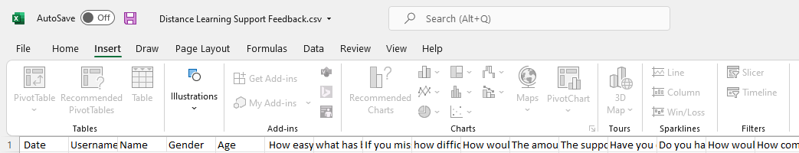

Update the columns names for analysis

1. I have used survey question which gives the detail about the students to know how much they are feeling comfortable with remote learning.
2. I have used survey question about the various devices used by the students which gives the insights about were the students capable enough to use the devices for distance learning.

3. I have used preferred learning environment as the key question in the survey which gives the clear picture about their experience so far with distance learning.

4. I have analyzed the percentage of communication made between teachers and students so far which turn out excellent based on the analysis.

5. I have analyzed student engagement because it is a vital think about taking the choice and facilitate the scholar with higher facilities.

Below is the representation of the data received from the students and I have used the Tableau platform to process and analyze the data.

**Analysis For Survey:**

* As per the info generated with the assistance of the survey kind below are the Impact and suggestions concerning distance learning.
* Supported the information received, and from the analysis, it's evident that students felt positive concerning distance learning therefore far.

When we asked concerning the technology that has been utilized by the scholars, there are some fascinating results too as 90% of the students were victimization laptop computer computers in distance learning with comparatively smart web speed overall wherever they haven’t two-faced such major issue with the net categories conducted or submissions. Interestingly, on the average students have spent 4-5 per day to this point and atiny low portion of the students have spent 6hrs on a median in distance learning.

Surprisingly, there are some other facts that gave different insights about distance learning here:

* Even though students are feeling about distance learning, 57% students have participated consistently in distance learning classes.
* There is less percentage of students who doesn’t seems to communicate with teachers while there are more than 50% who had communicated at least once respectively.
* Conclusively, almost most of the Students are facing challenges with their studying schedule and around 5% of the students are having issues with effective learning while rest of them are facing challenges with in-person communication.

**Recommendations:**

As there's no such major impact on students with distance learning as they need the most recent technology obtainable with variable resources, however they're want to attend in-person categories as well, schools/colleges/universities ought to trust the implantation of hybrid format for terms.